def starts_with(char, string):
return (lambda c, s: s.startswith(c))(char, string)
char = 'N'
string = 'Nilay Kanire'
result = starts_with(char, string)
print(f'Does the string "{string}" start with "{char}"? {result}')

#Output ->

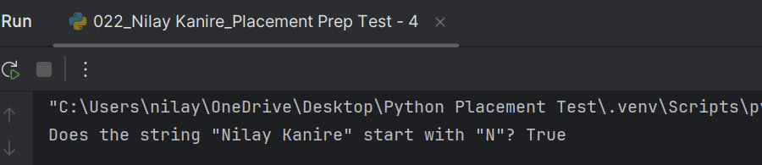

def filter_len(arglist):
filtered_list = list(filter(lambda x: len(x) == 6, arglist))
print(filtered_list)
mylist = ["1234567", "123456", "123", "NilayK", "Good"]
filter_len(mylist)

# Output ->
